How to create Nat Gateway

Create VPC
- Make sure you are in the US East (N. Virginia) us-east-1 region.
- Navigate to VPC under the services menu. Click on Your VPCs.
- Click on Create VPC.
  - Name Tag : MyVPC
  - IPv4 CIDR block : 10.0.0.0/16
  - IPv6 CIDR block : Select No IPv6 CIDR Block
  - Tenancy : Default
  - Click on Create VPC.
- The VPC is now created.

Create Public and Private Subnets

- Navigate to Subnets in the left panel of the VPC page.

- Let's create Public subnet. Click on Create subnet.
  - VPC ID : select MyVPC
  - Subnet Name : MyPublicSubnet
  - Availability Zone : No Preference
  - IPv4 CIDR block : 10.0.0.0/24
  - Click on Create subnet.

- Let's enable Auto Assign public IP to Instances created within this subnet,
  - Select MyPublicSubnet , Click on Actions.
  - Click on Modify auto-assign IP settings
  - Enable auto-assign public IPv4 address : Check
  - Click on Save.

- Let’s create a private subnet. Click on Create subnet.
  - VPC ID : select MyVPC
  - Subnet Name : MyPrivateSubnet
  - Availability Zone : No Preference
  - IPv4 CIDR block : 10.0.1.0/24
  - Click on Create subnet.
- two subnets are created.

Create Internet Gateway
- Navigate Internet Gateways in the left panel of the VPC page.
- Click on Create internet gateway.
  - Name tag : MyIGW
  - Click on Create internet gateway.
Internet Gateway will be created.

To attach Internet Gateway to a VPC,
  - Select the Internet Gateway MyIGW.
  - Click on Actions. Select Attach to VPC.
  - VPC : MyVPC
  - Click on Attach internet gateway, So MyIGW is attached to MyVPC.

Create Public Route Table and Configure
We will create a route table and attach a public subnet to it. Instances launched within this subnet will have access to the Internet.
- Navigate to Route Table in the left panel of the VPC page.
- Click on Create route table.
  - Name tag : PublicRouteTable
  - VPC : MyVPC
  - Click on Create route table.
- A route table by name PublicRouteTable will be created.
- To attach an Internet Gateway, select PublicRouteTable.
- In the Routes tab below:
  - Click on .
  - On the next page, click on
  - Destination : Enter 0.0.0.0/0
  - Target : Select Internet Gateway, and once the internet gateways have been created, select MyIGW
  - Click on Save changes.
- To associate the Public Subnet to the route table, Select PublicRouteTable.
  - Click on the Subnet Associations tab.
  - Click on .
  - On the next page, select MyPublicSubnet from the list displayed.
  - Click on Save associations.
As you can see, there is another existing route table already available for MyVPC. It is a main route table created at the time the VPC was created. We will use it while creating the NAT Gateway.

Launching an EC2 Instance in Public Subnet
- Make sure you are in the N.Virginia region go to instances and click on Launch instances.
- Choose an Amazon Machine Image (AMI): Search for Amazon Linux 2 AMI in the search box and click on the select button.
- Choose an Instance Type: select and click on the 
- Configure Instance Details:
  - Network : MyVPC
  - Subnet : MyPublicSubnet
  - Auto-assign Public IP : Use Subnet Setting(Enable) - default
  - Leave all other settings as default.
- Create new Security Group with SSH and source should be anywhere.
Choose Type: SSH
Source: Anywhere
- Create a new key pair (MyKey.pem) to avoid any unwanted issues and login with the public IP as usual.

Launching an EC2 Instance in Private Subnet
- Click on Launch instances.
- Choose an Amazon Machine Image (AMI)
- Configure Instance Details:
  - Network : MyVPC
  - Subnet : MyPrivateSubnet
  - Auto-assign Public IP : Use Subnet Setting(Disable) - default
  - Leave all other settings as default.
- Create separate Security Group:
    - Choose Type: SSH
    - Source: custom : 0.0.0.0/0
- Key Pair : Select the existing key created earlier MyKey.pem.
- Note the Private IP Address of MyPrivateEC2Server like 10.0.1.45

So currently Two servers are now launched and running and we are login into public subnet ec2-instance.

SSH into Public and Private EC2 Instance and Test Internet Connectivity
  - Login into public subnet one Ec2-instance (first one)
  - Sudosu
  - yum -y update
Since the Internet Gateway MyIGW is connected to MyPublicSubnet, updates will be completed successfully.

Now try SSH into MyPrivateEC2Server from MyPublicEC2Server.
In order to SSH into MyPrivateEC2Server, first we need to create the PEM file in the public EC2.

To create the MyKey.pem in MyPublicEC2Server
viMyKey.pem
(Simply we have to open that .pem file which we have downloaded during creation of ec2-instances and paste here and save this file)
Check that the file was created correctly.
  - ls
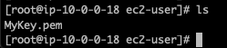
Update Permissions for the MyKey.pem
chmod 400 MyKey.pem
Use the Private IP address 10.0.1.45 to SSH.
ssh -i MyKey.pem ec2-user@10.0.1.45
You will see “Are you sure you want to continue connecting (yes/no)?” : Enter yes
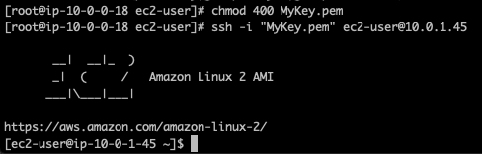
Switch to root user
  - Sudosu
Run the updates using the following command:
  - yum -y update
As no internet access is provided for EC2 instances in a private subnet, you will not be able to get updates. After some time, it will fail with the following message.

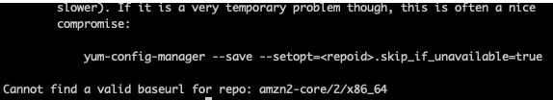

Creating NAT Gateway
NAT Gateway is used to provide internet access to the Instances inside a private subnet.
- Go to VPC Page &In the Left Panel, click on NAT Gateways.
- Click on Create NAT gateway.
  - Name : MyNATGateway
  - Subnet : Choose MyPublicSubnet in MyVPC
  - Elastic IP Allocation ID : Click on Allocate Elastic IP.
  - Once the new Elastic IP is allocated, click on Create NAT gateway.

Note that NAT Gateway is always created in a public subnet.

Update Route table and configure NAT Gateway
- Go to Route Tables in the left panel.
- You can see two Route Tables available for MyVPC
- To attach Nat Gateway, select the Main Route Table (which is different from the one created by you).
- In the Routes tab below,
  - Click on .
  - In the next page, Click on
  - Destination : 0.0.0.0/0
  - Target : Select NAT Gateway, and once the internet gateways have loaded, select the NAT Gateway you created.
  - Click on Save changes.

Now the Instances launched within MyPrivateSubnet can access the Internet through the NAT Gateway.

Test Internet connection from Instance inside Private Subnet
- SSH back into MyPublicEC2Server .
- Switch to root user
  - sudosu
- SSH into MyPrivateEC2Server
  - ssh -i "MyKey.pem" ec2-user@10.0.1.45
- Switch to root user
  - sudosu
- Run the updates using the following command:
  - yum -y update
- You can see that the updates have been completed successfully in the terminal.
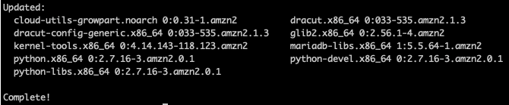
- This shows that MyPrivateEC2Server has internet access.

**************************************** Cheers ***********************************************

